Sentiment Analysis using Voice Recognition

Muhtasim-Ul-Alam
Computer Science and Engineering
East West University
Dhaka, Bangladesh
muhtasimalam19@gmail.com

Farzana Rahman
Computer Science and Engineering
East West University
Dhaka, Bangladesh
Farzanarahman876@gmail.com
Tasnim Ikra
Computer Science and Engineering
East West University
Dhaka, Bangladesh
tasnimikra1997@gmail.com

Abstract— In order to obtain emotional-related response from robots, computers and other intelligent machines, the first and decisive step is accurate emotion recognition. Sentiment analysis has evolved over past few decades, most of the work in it revolved around textual sentiment analysis with text mining techniques. But audio sentiment analysis is still in a nascent stage in the research community. In this study, we place ourselves in a difficult context, on the sentiments that could thinking of different emotions from the audio recording. Emotions are subjective, people would interpret it differently. In this study CNN algorithm is used for recognize emotion. For features Extraction MFCCs is used here. It’s determined the shape what sound comes out. Loading audio data and converting it to MFCCs format is done by the Python package librosa. The design customized in Python utilizing Keras model-level library and Tensor Flow backend.

Index Terms— Sentiment Analysis, Speaker Recognition, Speech Recognition, MFCC, DTW.

Introduction
Sentiment analysis is a topic of great interest and development since it has many practical applications. With the help of sentiment analysis systems, the unstructured information could be automatically transformed into structured data of public opinions about products, services, brands, politics, or any topic that people can express opinions about. So, we select a project where we can detect people’s emotions by their voice.

This paper presents the implementation of emotion detection from voice with a deep Convolutional Neural Network architecture (CNN) that process and classifies voice samples. The architecture model-level library [4] and TensorFlow backend. Sentiment analysis is used in various applications. For a machine to understand the mindset/mood of the humans through a conversation, it needs to know what is spoken, based on the state we decided to implement the emotion detection from voice, as most appropriate in the context of the applications intended.
In such a case, after detecting humans’ emotions, the machine could customize the settings according his/her needs and preferences. The research community already worked on transforming audio materials such as songs, debates, news, political arguments, to text.
Finding proper dataset is difficult here. it will be also a challenge to get higher accuracy. Recognize voice from various environment and handle noisy situation will be difficult.
This type of applications can be used as potential in the world that would benefit companies and also even safety to consumers. This study can be very useful for commercial applications like marketing analysis, public relations, product reviews, net promoter scoring, product feedback, and customer service.
It can be categorized into two main types: facts and opinions.
- Facts are objective expressions about something.
- Opinions are usually subjective expressions that describe people’s sentiments, appraisals, and feelings toward a subject or topic.
It's the automated process of classifying opinions as positive or negative. Analyzing sentiment in voice or audio data sources provides businesses with key insights to understand what’s behind customers' decisions and behavior. Building and training Speech Emotion Recognizer that predicts human emotions using Python which is one of the libraries used for audio analysis.
Usually, besides identifying the opinion, these systems extract attributes of the expression e.g.:
Polarity: if the speaker expresses a positive or negative opinion,
Subject: the thing that is being talked about,
Opinion holder: the person, or entity that expresses the opinion. Finding proper dataset is difficult here. it will be also a challenge to get higher accuracy. Recognize voice from various environment and handle noisy situation will be difficult.
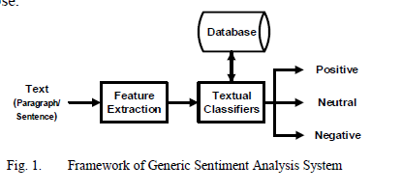

Related work
Many researches were already done on voice recognition. A similar work was “Deep Learning and Sentiment Analysis for Human-Robot Interaction”. The main topic of this paper is how effectively sentiment analysis and deep learning can be used for human-robot interaction. Here, the robot is capable of talking to the user and understanding sentiments by some external service. Research is mainly focusing towards supervised and unsupervised approaches for the semantic parsing of natural language commands into formal meaning representations. The robot can easily record the human voice, which is contextually analyzed and turned into text by a speech recognition module and to improve performances, and for speech recognition cloud computing is also used which processed the sound, in order to remove fan noise. To perform speech recognition. The resulting audio File is sent to IBM Watson Speech to Text5 and the result given by the speech recognition module is analyzed by means of QiChat6, a language specially designed to handle dialogs between the robot and humans. If the user input does not match any predefined action, then it is sent to restful web services, where the text is analyzed by a Sentiment Analysis engine and by a Generative Conversational Agent (GCA) to understanding sentiments hidden in the text. The sentiment analysis system has been implemented in Java and makes use of Stanford CoreNLP for standard preprocessing tasks, such as sentence detection, tokenization, POS tagging and stop-words removal Classification relies on recurrent neural networks (RNNs) and, more precisely, LSTM (Long Short-Term Memory), while feature extraction is achieved using neural word embeddings, obtained by applying the global log-bilinear regression model GloVe. The system has been trained for both polarity detection and subjectivity detection. The performances of the system have been measured using 10-fold cross-validation, achieving an accuracy of 0:88 for polarity detection and 0:90 for subjectivity detection[1].
Another similar research was “Human Vocal Sentiment Analysis”. In this paper, we use several techniques with conventional vocal feature extraction (MFCC, STFT), along with deep-learning approaches such as CNN, and also context-level analysis, by providing the textual data, and combining different approaches for improved emotion-level classification. MFCC’s on audio data provide rich feature content about their data in a fixed manner, compared to raw audio wave forms. SVM’s provide a fast way to fit data with non-linearities such as MFCC data. But because of the limitations of how they separate non-linear data, Convolutional neural networks capture rich features about their dataset with a high accuracy with the use of a large amount of data, and the same methods applied to photo recognition can also be applied to MFCC filters. With a smaller and more condensed model, a framework for real-time emotion recognition could be achieved. Machine learning for language recognition tasks seems very promising in the future, as computational speed and more larger sources of data become widespread[2].

Another research was “Interactive Voice Response using Sentiment Analysis in Automatic Speech Recognition Systems”. For taking input call centers use DTMF tone inputs to instruct their system and respond to the user appropriately in previous days. But the paper explained the implementation of ASR for interaction in call centers. ASR permits user to interact with the computer system and IVR (Interactive Voice Response) system. ASR enabled system uses machine learning and sentiment analysis to serve the customer needs efficiently. Sentiment Analysis is the technology which enables the computer systems to read and comprehend human emotions and make decisions based on those emotions. The process of sentiment analysis is broken into different sections such as data collection, data preprocessing, sentiment and emotion identification. After completing the research the paper shows that ASR system works more efficiently than DTMF systems[3].

methodology

The independent variable for the experiment is the data set and the dependent variable is the accuracy which the convolutional neural network will achieve on the test dataset. The reason why the convolutional neural network was chosen is that the neural network has been showing good results in previous research on sentiment analysis.

Proposed system
In this paper, we propose a model for sentiment analysis that utilizes features extracted from the speech signal to detect the emotions of the speakers involved in the conversation. The process involves four steps: 1) Pre-processing which includes 2) Speech Recognition System, 3) Speaker Recognition System, 4) Sentiment Analysis System [4]

Data set
RAVADESS dataset is used for our project. This dataset includes around 1500 audio file input from 24 different actors. 12 male and 12 female where these actors record short audios in 8 different emotions i.e 1 = neutral, 2 = calm, 3 = happy, 4 = sad, 5 = angry, 6 = fearful, 7 = disgust, 8 = surprised.

Feature extruction:
The extraction of unique speaker discriminant feature is
important to achieve a better accuracy rate. The accuracy of this phase is important to the next phase, because it acts as the input for the next phase.

MFCC- Humans perceive audio in a nonlinear scale, MFCC tries to replicate the human ear as a mathematical model. The actual acoustic frequencies are mapped to Mel frequencies which typically range between 300Hz to 5KHz. The Mel scale is linear below 1KHz and logarithmic above 1KHz. MFCC Constants signifies the energy associated with each Mel bin, which is unique to every speaker. This uniqueness enables us to identify speakers based on their voice

Implementation
We have used Convolution Neural Network (CNN) for our project. CNN model was the best for this type of classification problem. We tested out the audio files by plotting out the waveform and a spectrogram to see the sample audio files.
The CNN neural network has an architecture inspired from primate visual cortex. The visual cortex has multiple cortex levels (layers), each one capable to recognize more structured information[5].The specificity of the CNN is the presence of the convolutional (two dimensional)layer followed by the pooling layers, as CNN pair-layer, at the bottom of the stack (sequence) of the neural network layers. The convolutional layer has the purpose to extract the structured information with sub matrices.
filters (strides) parsing on the two-dimensional input data. The pooling layer summarize the output of the convolution matrix by aggregating the values of the stride sub-matrix into a single value [5].

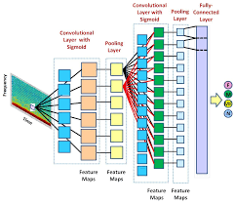
fig.2. CNN model

Convolutional layers are used to filter the initial data, to extract features from input. The fully connected layers are used for classification, obtaining predictions for the problem we are working on (so, a list of features values become a list of votes).
Our CNN model was tuned to detect emotions with more than 62.50% accuracy. The best part is that it distinguishes between a males and females voice excellently. So the For all the reasons we think CNN is the best performing algorithm for our dataset.

Evalution
We have done some the nonlinear activation functions in our study:
- Sigmoid or Logistic Activation Function
- Tanh or hyperbolic tangent Activation Function
- ReLU (Rectified Linear Unit) Activation Function

Result of those functions are given bellow:
For sigmoid:

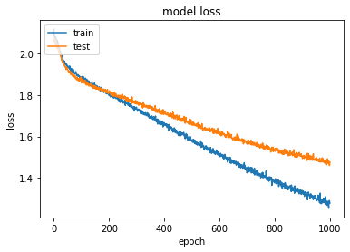
fig.3. Model loss for sigmoid

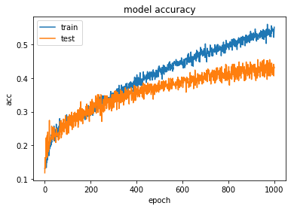
fig.4. Model accuracy for sigmoid
We have got accuracy 43.60% for sigmoid function which we can clearly see from fig.3 and fig.4.

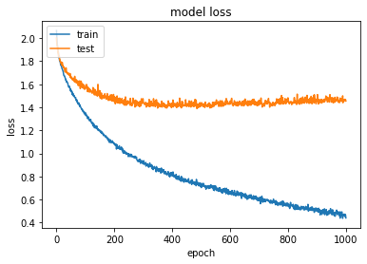
For Tanh:
fig.5. Model loss for tanh
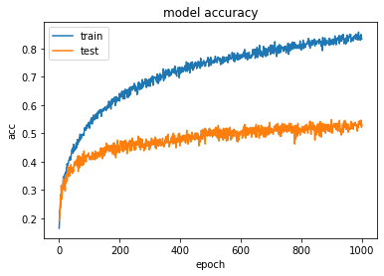

fig.6. Model accuracy for tanh

We have got accuracy 53% for tanh function which we can clearly see from fig.5 and fig.6.
For ReLU:

fig.7. Model Loss for ReLU

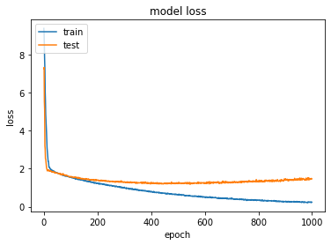

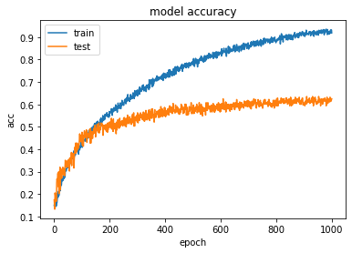

Fig.8. Model accuracy for ReLU

We have got accuracy 62.50% for ReLU function which we can clearly see from fig.7 and fig.8.

We have got an accuracy of 62.5% by implementing CNN as well as we also have implemented some activation function which are sigmoid, tanh and ReLU and got an accuracy of 43.60, 53%, 62.50% respectively. But other researches use RNN, LSTM and got higher accuracy than us.

Conclusion and future work
Our CNN model was tuned to detect emotions with more than 62.50% accuracy. The best part is that it distinguishes between a males and females voice excellently. So the for all the reasons we think CNN is the best performing algorithm for our dataset. For future work we may preprocess the data like cropping silence voice, normalize the length by zero padding, etc. which is not possible now for time limitation. And, Experiment the Recurrent Neural Network approach on this topic may also present a good result. Overall, this project had a good direction for accurate human voice emotion recognition. In this study if we used LSTM or RNN we might get a better accuracy. In future this work can be implemented by LSTM or RNN.

References
[1] M. Atzeni and D. Reforgiato Recupero, “Deep learning and sentiment analysis for human-robot interaction,” Lect. Notes Comput. Sci. (including Subser. Lect. Notes Artif. Intell. Lect. Notes Bioinformatics), vol. 11155 LNCS, pp. 14–18, 2018.
[2] A. Huang and P. Bao, “Human Vocal Sentiment Analysis,” pp. 1–16, 2019.
[3] R. R. Sehgal, S. Agarwal, and G. Rai, “Interactive Voice Response using Sentiment Analysis in Automatic Speech Recognition Systems,” Proc. 2018 Int. Conf. Adv. Comput. Commun. Eng. ICACCE 2018, no. June, pp. 213–218, 2018.
[4] S. Maghilnan and M. R. Kumar, “Sentiment analysis on speaker specific speech data,” Proc. 2017 Int. Conf. Intell. Comput. Control. I2C2 2017, vol. 2018-January, pp. 1–5, 2018.
[5] A. Gulli, Title Page Deep Learning with Keras Implement neural networks with Keras on Theano and TensorFlow. .

fig.7. Model loss for ReLU

